***ATM Transaction Display***

***Mini-Project***

**Description:**

The project is titled as "ATM Machine Transaction Display" and developed using C language. The Automated Teller Machine (ATM) allows bank customers to access their accounts without visiting the bank.

When a user needs to withdraw cash, they can enter their PIN number (personal identification number) and the amount to be withdrawn will be displayed in the form of 100s, 200s, 500s and 2000s.

Once their withdrawn was successful, the amount will be debited in their account or they can choose to display how much amount is in the account.

# Requirements:

## High Level Requirements:

1) We can open main Menu.

2) Deposit

3) Balance enquiry

4) Cash withdraw

5) Graphical User Interface

## Low Level Requirements:

1) Main menu should consists 4 options:

1. Deposit

2. Balance Enquiry

3. Cash Withdraw

4. Exit

2) Reading user input to select particular option

3) Output screen will display the overall balance

4) Read user input to withdraw entered amount exactly.

5) Should display final updated balance after credit or debit.

6) A clean graphical user interface with all required buttons for ease of use.

# Advantages:

1) Better, longer-lasting customer relationships

2) It can Offer 24/7 service

3) We can access it Easy and faster

4) Reduce bank workloads

# Disadvantages:

1) Limitations on cash withdraw

2) Possibility of frauds

**SWOT Analysis:**

STRENGTH:

Easy to use Application Faster Process

WEAKNESS:

Lack of Graphical User Interface

OPPURTUNITY:

GUI can be implemented

THREAT:

Best applications are available using different technologies competition is high.

**4 W's and 1 H:**

WHO:

Anyone with an ATM card can use the machine.

What:

It's an automatic machine to withdraw the money.

When:

It is available 24X7, 365 days.

Where:

It is available in various places.

How:

The program of this application was developed in C language to avoid the complexity and to keep it simple.

## ****Architecture:** 1) Structural**

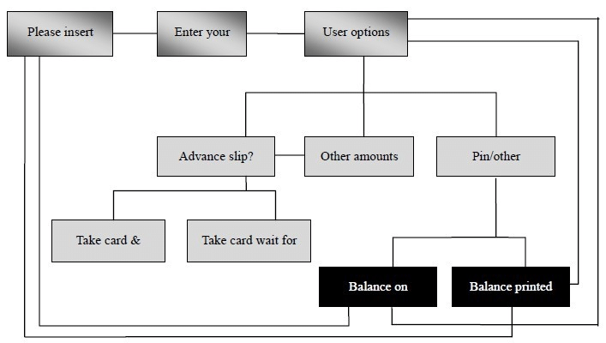

1. Behavioral: flowchart

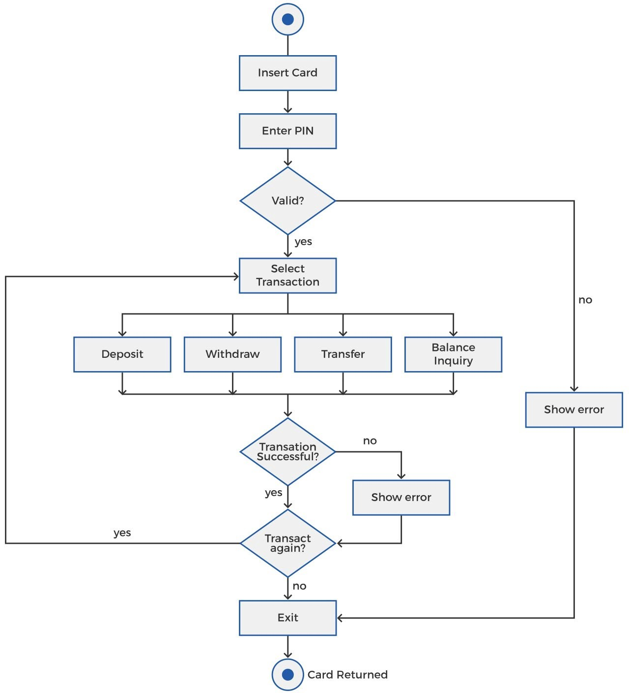

1. **Diagram:**

